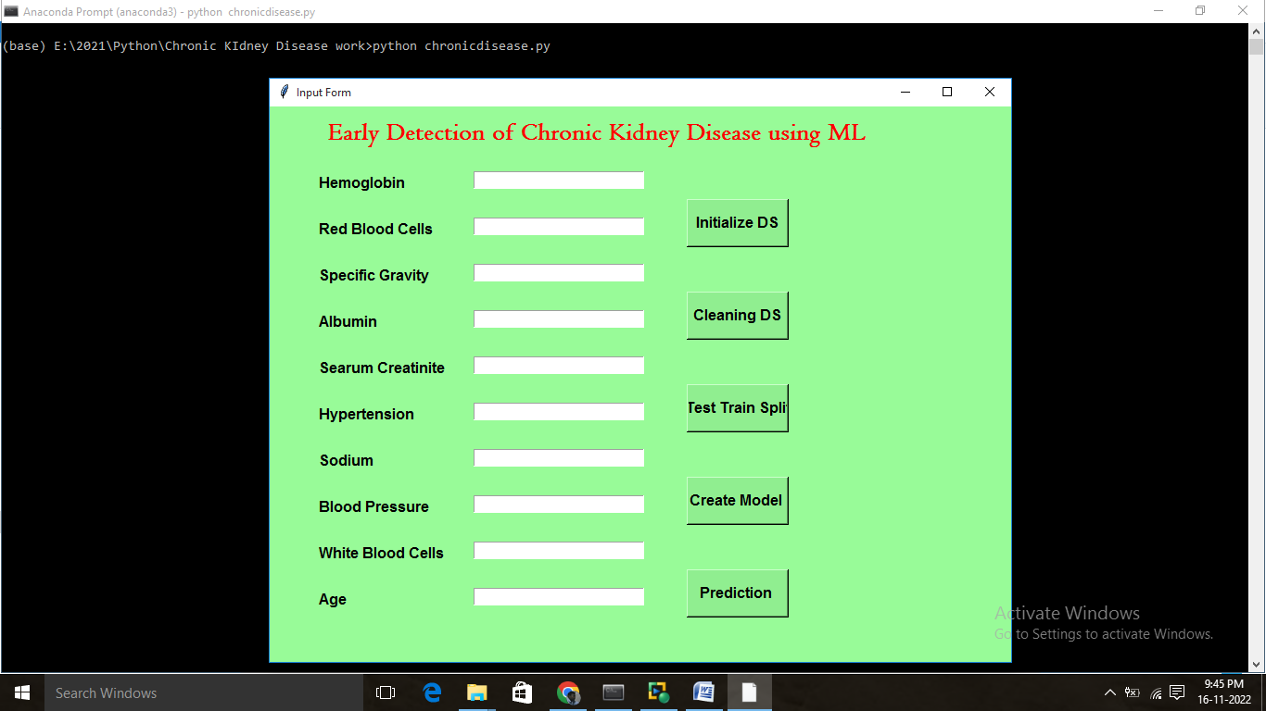

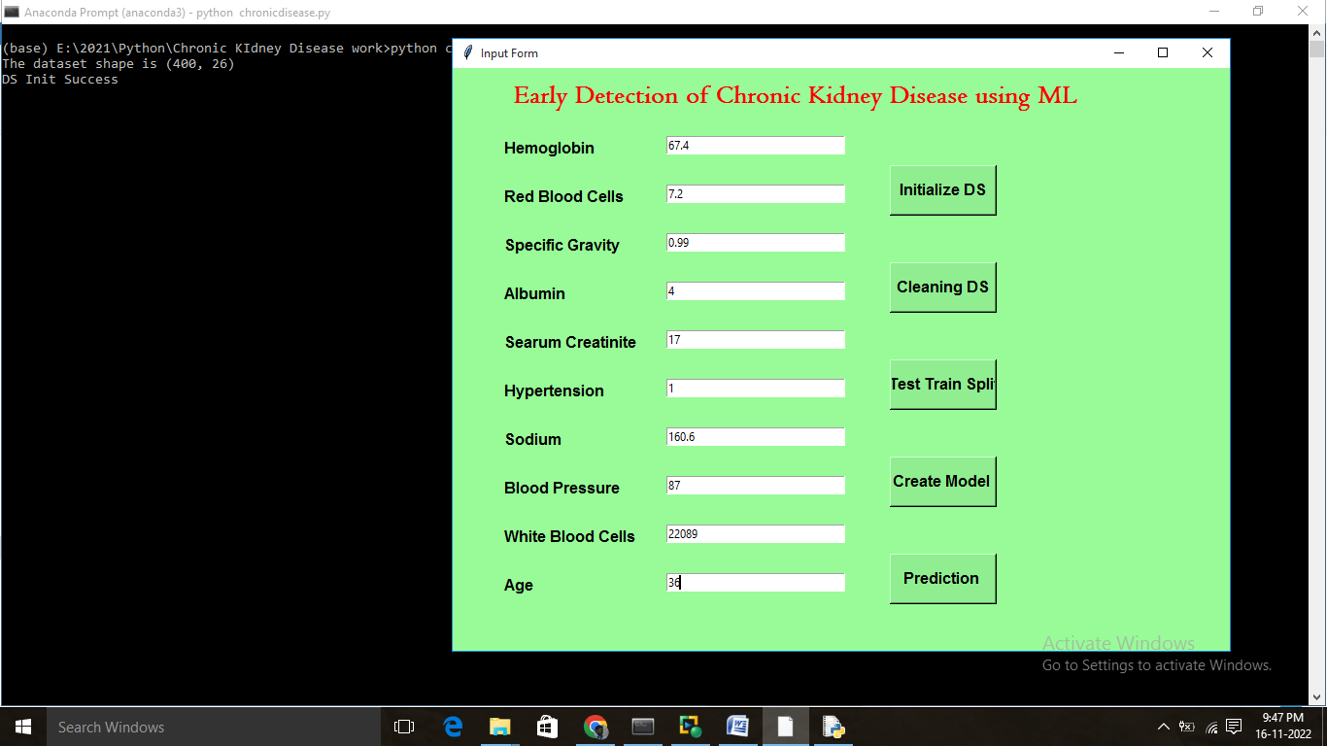

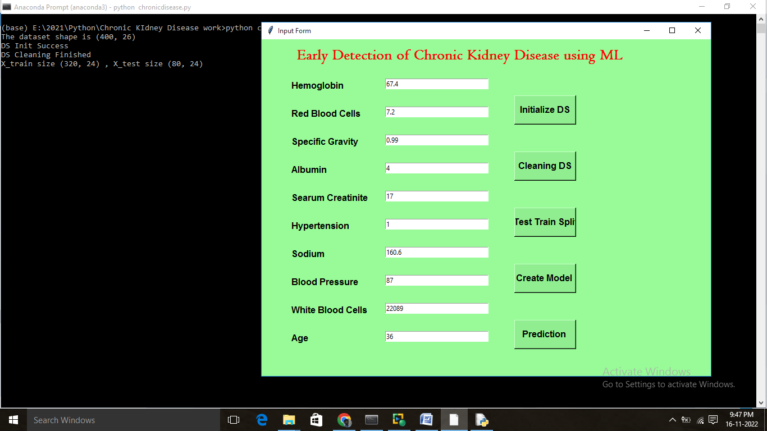

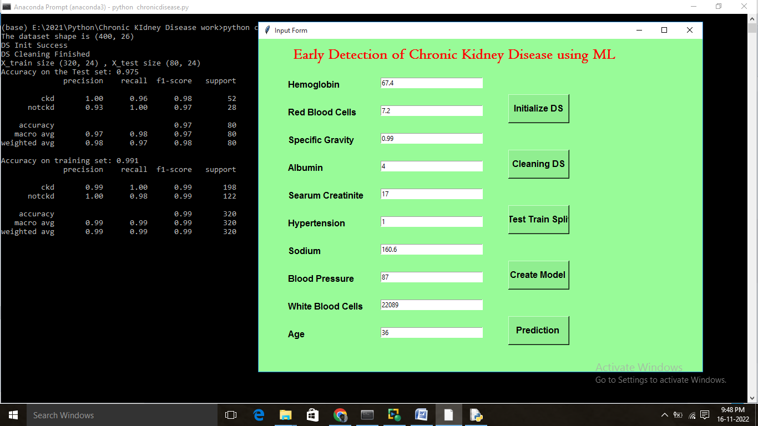

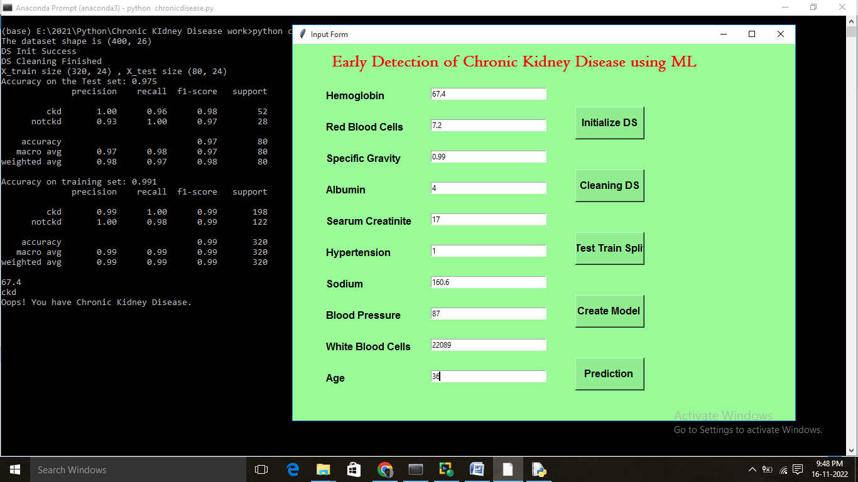

**Code**

from tkinter import *

import sqlite3

import re

from tkinter import messagebox

import numpy as np

import pandas as pd

import matplotlib.pyplot as plt

#import seaborn as sns

import warnings

warnings.filterwarnings('ignore')

class patient1:

# root = Tk()

def __init__(self,root):

self.root= root

root.title("Input Form")

root.geometry('500x500')

#Button(root, text='Reset',width=20,bg='brown',fg='white',command=validation).place(x=180,y=430)

# Centering Root Window on Screen

w = 800 # width for the Tk root

h = 600 # height for the Tk root

# get screen width and height

ws = root.winfo_screenwidth() # width of the screen

hs = root.winfo_screenheight() # height of the screen

# calculate x and y coordinates for the Tk root window

x = (ws/2) - (w/2)

y = (hs/2) - (h/2)

root["bg"] = '#98fb98'

# set the dimensions of the screen

# and where it is placed

root.geometry('%dx%d+%d+%d' % (w, h, x, y))

self.v = IntVar()

self.hb2=StringVar()

self.rbc2=StringVar()

self.sg2 =StringVar()

self.al2=StringVar()

self.sc2=StringVar()

self.ht2=StringVar()

self.sod2=StringVar()

self.bp2 =StringVar()

self.wbc2=StringVar()

self.age2=StringVar()

# labels for the window

self.heading = Label(self.root, text="Early Detection of Chronic Kidney Disease using ML", font=('Centaur 20 bold'), bg='#98fb98',fg='red')

self.heading.place(x=60, y=10)

self.hb1 = Label(self.root, text="Hemoglobin", font=('arial 12 bold'),bg='#98fb98')

self.hb1.place(x=50, y=70)

self.hb_ent = Entry(self.root, width=30, textvar=self.hb2)

self.hb_ent.place(x=220, y=70)

self.rbc1 = Label(self.root, text="Red Blood Cells", font=('arial 12 bold'),bg='#98fb98')

self.rbc1.place(x=50, y=120)

self.rbc_ent = Entry(self.root, width=30, textvar=self.rbc2)

self.rbc_ent.place(x=220, y=120)

self.sg1 = Label(self.root, text="Specific Gravity", font=('arial 12 bold'),bg='#98fb98')

self.sg1.place(x=50, y=170)

self.sg_ent = Entry(self.root, width=30, textvar=self.sg2)

self.sg_ent.place(x=220, y=170)

self.al1 = Label(self.root, text="Albumin", font=('arial 12 bold'),bg='#98fb98')

self.al1.place(x=50, y=220)

self.al_ent = Entry(self.root, width=30, textvar=self.al2)

self.al_ent.place(x=220, y=220)

self.sc1 = Label(self.root, text="Searum Creatinite", font=('arial 12 bold'),bg='#98fb98')

self.sc1.place(x=50, y=270)

self.sc_ent = Entry(self.root, width=30, textvar=self.sc2)

self.sc_ent.place(x=220, y=270)

self.ht1 = Label(self.root, text="Hypertension", font=('arial 12 bold'),bg='#98fb98')

self.ht1.place(x=50, y=320)

self.ht_ent = Entry(self.root, width=30, textvar=self.ht2)

self.ht_ent.place(x=220, y=320)

self.sod1 = Label(self.root, text="Sodium", font=('arial 12 bold'),bg='#98fb98')

self.sod1.place(x=50, y=370)

self.sod_ent = Entry(self.root, width=30, textvar=self.sod2)

self.sod_ent.place(x=220, y=370)

self.bp1 = Label(self.root, text="Blood Pressure", font=('arial 12 bold'),bg='#98fb98')

self.bp1.place(x=50, y=420)

self.bp_ent = Entry(self.root, width=30, textvar=self.bp2)

self.bp_ent.place(x=220, y=420)

self.wbc1 = Label(self.root, text="White Blood Cells", font=('arial 12 bold'),bg='#98fb98')

self.wbc1.place(x=50, y=470)

self.wbc_ent = Entry(self.root, width=30, textvar=self.wbc2)

self.wbc_ent.place(x=220, y=470)

self.age1 = Label(self.root, text="Age", font=('arial 12 bold'),bg='#98fb98')

self.age1.place(x=50, y=520)

self.age_ent = Entry(self.root, width=30, textvar=self.age2)

self.age_ent.place(x=220, y=520)

# button to perform a command

self.submit = Button(self.root, text="Initialize DS", font="aried 12 bold",width=10, height=2, bg='lightgreen',command=self.initds)

self.submit.place(x=450, y=100)

self.submit1 = Button(self.root, text="Cleaning DS", font="aried 12 bold",width=10, height=2, bg='lightgreen',command=self.logform)

self.submit1.place(x=450, y=200)

self.submit2 = Button(self.root, text="Test Train Split", font="aried 12 bold",width=10, height=2, bg='lightgreen',command=self.splitds)

self.submit2.place(x=450, y=300)

self.submit3 = Button(self.root, text="Create Model ", font="aried 12 bold",width=10, height=2, bg='lightgreen',command=self.classifyy)

self.submit3.place(x=450, y=400)

self.submit4 = Button(self.root, text="Prediction ", font="aried 12 bold",width=10, height=2, bg='lightgreen',command=self.predictt)

self.submit4.place(x=450, y=500)

def initds(self):

self.df=pd.read_csv("kidney_disease.csv")

print("The dataset shape is {}".format(self.df.shape))

# remove "id" feature

self.df.drop('id',axis=1,inplace=True)

print("DS Init Success")

def logform(self):

#in our dataset some features ['pcv','wc','rc','dm','cad','classification'] contains some special character.so replace them with appropriate values.

# cleaning 'PCV'

self.df['pcv']=self.df['pcv'].apply(lambda x:x if type(x)==type(3.5) else x.replace('\t43','43').replace('\t?','Nan'))

# cleaning "WC"

self.df['wc']=self.df['wc'].apply(lambda x:x if type(x)==type(3.5) else x.replace('\t?','Nan').replace('\t6200','6200').replace('\t8400','8400'))

# cleaning "RC"

self.df['rc']=self.df['rc'].apply(lambda x:x if type(x)==type(3.5) else x.replace('\t?','Nan'))

# cleaning "dm"

self.df['dm']=self.df['dm'].apply(lambda x:x if type(x)==type(3.5) else x.replace('\tno','no').replace('\tyes','yes').replace(' yes','yes'))

# cleaning "CAD"

self.df['cad']=self.df['cad'].apply(lambda x:x if type(x)==type(3.5) else x.replace('\tno','no'))

# cleaning "Classification"

self.df['classification']=self.df['classification'].apply(lambda x:x if type(x)==type(3.5) else x.replace('ckd\t','ckd'))

#Note: Some features are mistyped as "object".so convert them into "float" type

mistyped=[['pcv','rc','wc']]

for i in mistyped:

self.df[i]=self.df[i].astype('float')

# define categoricsl features

cat_cols=list(self.df.select_dtypes('object'))

cat_cols

# define numeric features

self.num_cols=list(self.df.select_dtypes(['int64','float64']))

self.num_cols

# Checking missing/Nan values

self.df.isnull().sum().sort_values(ascending=False)

# Let's impute Nan Values with median in numeric features

for col in self.num_cols:

self.df[col]=self.df[col].fillna(self.df[col].median())

# let's impute categorical features with most frequent value

self.df['rbc'].fillna('normal',inplace=True)

self.df['pc'].fillna('normal',inplace=True)

self.df['pcc'].fillna('notpresent',inplace=True)

self.df['ba'].fillna('notpresent',inplace=True)

self.df['htn'].fillna('no',inplace=True)

self.df['dm'].fillna('no',inplace=True)

self.df['cad'].fillna('no',inplace=True)

self.df['appet'].fillna('good',inplace=True)

self.df['pe'].fillna('no',inplace=True)

self.df['ane'].fillna('no',inplace=True)

self.df.isna().sum().sort_values(ascending=False)

print("DS Cleaning Finished")

def splitds(self):

self.df['rbc']=self.df['rbc'].map({'normal':0,'abnormal':1})

self.df['pc']=self.df['pc'].map({'normal':0,'abnormal':1})

self.df['pcc']=self.df['pcc'].map({'notpresent':0,'present':1})

self.df['ba']=self.df['ba'].map({'notpresent':0,'present':1})

self.df['htn']=self.df['htn'].map({'no':0,'yes':1})

self.df['dm']=self.df['dm'].map({'no':0,'yes':1})

self.df['cad']=self.df['cad'].map({'no':0,'yes':1})

self.df['pe']=self.df['pe'].map({'no':0,'yes':1})

self.df['ane']=self.df['ane'].map({'no':0,'yes':1})

self.df['appet']=self.df['appet'].map({'good':0,'poor':1})

# scaling with MinMaxScaler

from sklearn.preprocessing import StandardScaler,MinMaxScaler

mm_scaler=MinMaxScaler()

self.df[self.num_cols]=mm_scaler.fit_transform(self.df[self.num_cols])

from sklearn.model_selection import train_test_split

x=self.df.drop('classification',axis=1)

y=self.df['classification']

self.X_train,self.X_test,self.y_train,self.y_test=train_test_split(x,y,test_size=0.2,random_state=0)

print("X_train size {} , X_test size {}".format(self.X_train.shape,self.X_test.shape))

def classifyy(self):

from sklearn.ensemble import RandomForestClassifier

from sklearn.metrics import confusion_matrix,classification_report,accuracy_score

# Creating Random Forest model

self.rf=RandomForestClassifier(max_depth=5,n_estimators=5)

self.rf.fit(self.X_train,self.y_train)

self.y_pred=self.rf.predict(self.X_test)

# Accuracy score

score=round(accuracy_score(self.y_test,self.y_pred),3)

print("Accuracy on the Test set: {}".format(score))

# Classification report

print(classification_report(self.y_test,self.y_pred))

# Creating a confusion matrix for training set

self.y_train_pred=self.rf.predict(self.X_train)

# Accuracy score

score=round(accuracy_score(self.y_train,self.y_train_pred),3)

print("Accuracy on training set: {}".format(score))

print(classification_report(self.y_train,self.y_train_pred))

def predict1(self,hemo,rc,sg,al,sc,htn,sod,bp,wc,age):

print(hemo)

hemo=float(hemo)

rc=float(rc)

sg=float(sg)

sc=float(sc)

htn=int(htn)

sod=float(sod)

bp=float(bp)

wc=float(wc)

age=int(age)

x=[[hemo,rc,sg,al,sc,htn,sod,bp,wc,age]]

return self.rf.predict(x)

def predictt(self):

self.X_train=self.X_train[['hemo','rc','sg','al','sc','htn','sod','bp','wc','age']]

self.X_test=self.X_test[['hemo','rc','sg','al','sc','htn','sod','bp','wc','age']]

self.rf.fit(self.X_train,self.y_train)

hb3=self.hb2.get()

rbc3=self.rbc2.get()

sg3=self.sg2.get()

al3=self.al2.get()

sc3=self.sc2.get()

ht3=self.ht2.get()

sod3=self.sod2.get()

bp3=self.bp2.get()

wbc3=self.wbc2.get()

age3=self.age2.get()

prediction = self.predict1(hb3,rbc3,sg3,al3,sc3,ht3,sod3,bp3,wbc3,age3)[0]

#prediction = self.predict1(67.4,7.2,0.99,4,17.0,1,160.6,87,22089,36)[0]

print(prediction)

if prediction:

print('Oops! You have Chronic Kidney Disease.')

else:

print("Great! You don't have Chronic Kidney Disease.")

if __name__ == '__main__':

root = Tk()

application=patient1(root)

#root.geometry('500x500')

root.mainloop()